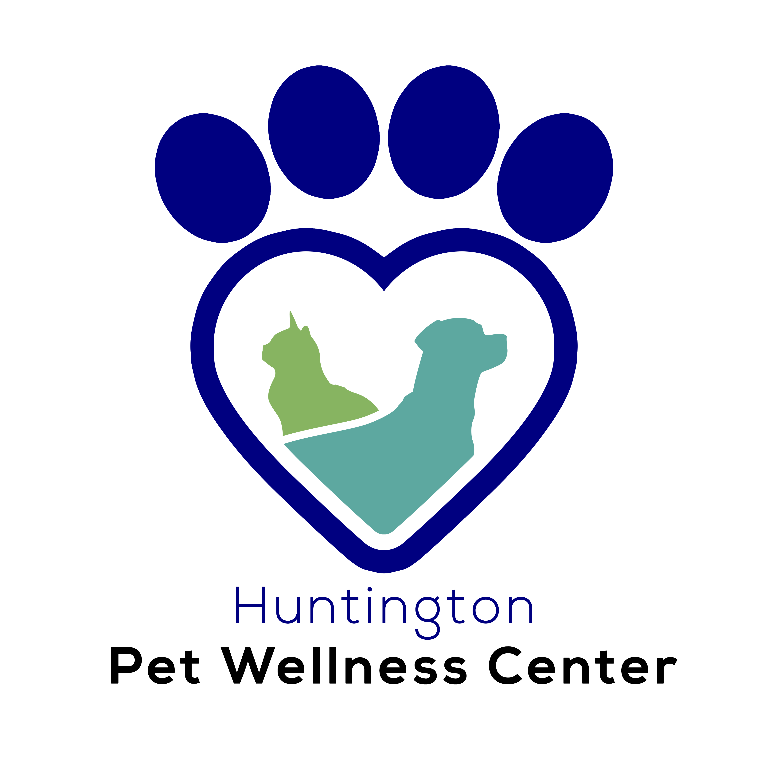
Pet Wellness Center
8052 Adams Ave.
Huntington Beach, CA 92648
(714) 969- 0211 Ex. 2
support@huntingtonpetvet.com
www.huntingtonpetvet.com

Before your visit to Huntington Pet Wellness Center, please review our Grooming Release Form thoroughly. You may print it out, initial each paragraph, sign at the bottom, and bring it with you. Or you may send a completed copy by email. We will also have them available at the grooming facility at the time of check in.

Parent Name:___________________________________________ Date:_______________________________

Address:______________________________ City/St: ________________________________Zip:__________

Cell Phone: __________________________Email:________________________________________________

Pet’s name:_________________________________________ Breed:_________________________________

Sex:_______________Spayed/Neutered?_______DOB:_________________Weight:_____________________

*Has pet been to the groomer before? ___________If so, when was the last grooming?____________________

*Has pet ever bitten anyone?______________ If so, when/what was the situation?________________________

*Any skin sensitivity/allergies?________________________________________________________________

*Chronic ear infections/ problems?_____________________________________________________________

*Any overall health concerns?_________________________________________________________________

Huntington Pet Wellness Center Grooming Release From

Your pet is very important to us. Huntington Pet Wellness Center would like to assure you that every effort will be made to make your pet’s grooming experience as safe and pleasant as possible. Safety comes first for everyone during the grooming process, for people as well as your pet. Please initial each paragraph and sign at the bottom of the form.

Vaccinations: All pets are REQUIRED to be current on vaccinations in order to receive grooming services.
__________Owner’s Initials
Health or Medical Problems:
Occasionally grooming can expose a hidden medical problem or aggravate a current one. This can occur during or after grooming. Please be aware that grooming can cause mild irritation or itchiness—please watch your pet to make sure he or she is not scratching excessively. The pet’s owner upon signature of this contract/agreement will cover all medical expenses for veterinary care. We also reserve the right to refuse service to customers whose pets might pose a threat to us or the other pets in our care, whether it’s an aggression problem, health problem, or parasite problem.
__________Owner’s Initials
Accidents/Medical Emergencies:
Although accidents are rare, there is a risk when dealing with animals. Grooming equipment is sharp, and although we use extreme caution in all situations, possible problems could occur. If your dog is wiggling or moving around, including cuts, nicks, scratches, quicking of nails, etc. Your pet’s comfort and safety is our number one priority. In an event that an accident occurs, you will be notified of the accident. If Huntington Pet Wellness Center feels that the accident is serious, and the owner is not available, we will seek immediate veterinary care at Huntington Pet Vet.
__________Owner’s Initials
Additional Fees:
We reserve the right to charge additional fees for services over and above the norm covered by our standard rates. These additional fees would include de-matting/de-shedding, flea baths, medicated baths etc. Pricing given over the phone is only an estimate. The final price will be given at time of check out after the groom has been completed.
__________Owner’s Initials
Aggressive Dogs:
Owners MUST inform Huntington Pet Wellness Center if your dog has bitten, or is aggressive to people, other dogs, or during specific grooming procedures. In the event that your dog becomes aggressive during the grooming session, Huntington Pet Wellness Center reserves the right to refuse grooming services, or stop the grooming session at any time before or during the grooming session. We do not muzzle unless your dog gives us a reason to. A muzzle may be used as a last resort, which does not harm the dog in any way, and may allow the grooming session to continue.
__________Owner’s Initials
Matted Coats:
Dogs with severely matted coats require extra attention. Mats are very painful to the dog and will ultimately cause damage and even tear the dog’s skin, providing a breeding ground for infection and parasite (flea & tick) infestations. In addition, matted hair does not allow for air circulation to the skin, causing hot spots, bacterial and fungal infection. Mats are difficult to remove and may require the dog to be shaved. Removing a heavily matted coat can cause bruising, nicks, and abrasions as we are working very close to the skin, even though we are extremely cautious. After effects of mat removal can include itchiness, skin redness, self-inflicted abrasions, and in some cases, failure of the hair to re-grow. In some cases, the dog may even experience brief behavioral changes. Prevention is the best defense by scheduling regular grooming sessions. If your pet needs to be shaved, we will contact you to let you know. By initialing this, you acknowledge that you agree to this procedure, if necessary.
__________Owner’s Initials
Cancellations/No Shows:
No-shows and cancellations without 24-hour notice will be charged a $20.00 fee. No-shows and cancellations at short notice leave an empty grooming appointment that could have been used by another customer. This fee must be paid before another grooming appointment can be made.
__________Owner’s Initials
Pick Ups:
Pick ups must be made before closing at 6pm Monday-Friday and 3pm on Saturdays. Special circumstances may occur where a pet takes longer to finish than expected. We will call if your pet will be completed after closing, and we will arrange a pick up time. For all other late pick-ups, we will board your pet, comfortably, overnight at an extra charge.

Photographs:
This release form authorizes Huntington Pet Wellness Center to take photos of your dog for our website and/or Facebook page.
__________Owner’s Initials
Satisfaction:
Your satisfaction is important to us. If you are unhappy for any reason, and would like something adjusted, we will be happy to make the adjustment at the time of pickup. Please carefully look over your pet to make sure he or she is leaving in as good or better condition than when arriving.
__________Owner’s Initials

I have reviewed this Service Contract for accuracy and understand the contents. I affirm that I am the rightful legal owner of the dog for which grooming services are being rendered. I authorize this signed contract to be valid approval for future grooming services, permitting Huntington Pet Wellness Center to accept reservations without additional signed contracts or written authorization. I understand that prices are subject to change, I have read, signed and agreed to the above.

Print full name of owner___________________________________________________________________

Signature of owner_______________________________________ Date____________________________

